E-MAIL TEMPLATES – 2020/2021 UNITED WAY CAMPAIGN

- Welcome/Overview

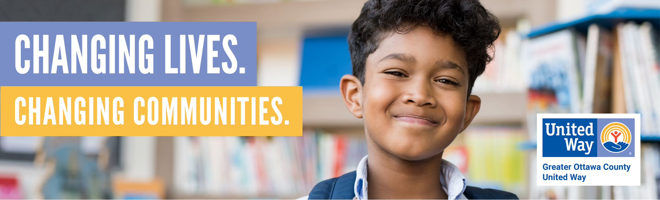

United Way fights for the health, education and financial stability of every person in every community. We win by living United. By forging unlikely partnerships. By finding new solutions to old problems. By mobilizing the best resources. And by inspiring individuals to join the fight against their community’s most daunting social crises. We are more than fundraisers. We are hand-raisers. Game-changers.

Here in Ottawa County, Greater Ottawa County United Way is fighting the fight and scoring big wins. With your help, we can do even more.

- In the past year, over 72,000 people in Ottawa County were reached by Greater Ottawa County United Way’s funded partner programs.
- Last year, 9,922 volunteers gave 107,375 hours worth more than $2.6 million.
- Last year, during the Stuff the Bus drive, more than 550 children received a backpack full of school supplies.
- 302 people each saved an average of $1,555 by using United Way’s MyFreeTaxes.com program.
- For every dollar donated to United Way, the community receives $4.37 in community benefit. Now, that is a great investment!
- To learn more about how we are making an impact, view our 2020 Impact Report here: www.ottawaunitedway.org/impact-report

So become a hand-raiser or a game-changer. Because United we fight, United we win. We have one life. To live better, we must Live United®.

YOU CAN MAKE AN IMPACT:

- Fill out your pledge form to make a donation to United Way. Your gift makes an impact in the areas of education, financial stability, health and basic needs in Ottawa County.
- Interested in volunteering? Look for opportunities in your workplace, or view opportunities online by visiting www.OttawaUnitedWay.org and clicking on “Volunteer.”

- A Thriving Family

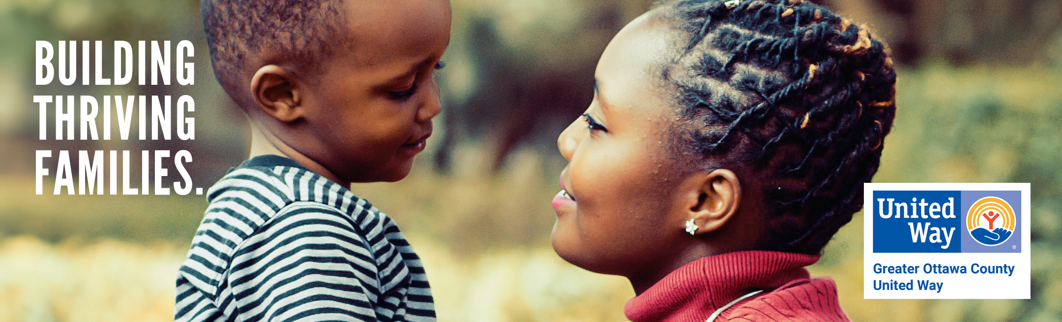

- Did you know that 31% of people in Ottawa County are struggling to make ends meet?
- United Way fights to help those who are struggling. Read the story below to see how one local woman and her children went from homeless to thriving.

After fleeing a domestic violence situation, Katie* was living in a local shelter with her children and no source of income. In less than a month, she and her children were able to move into permanent housing after being screened and assessed through a United Way partner program. Over the next six months, her family received both financial assistance and supportive services through United Way partner programs. With this support, she was able to secure full time employment and childcare.

*Name changed

- Greater Ottawa County United Way provides funding for 48 programs of 37 nonprofit organizations in Ottawa County that make an impact in the areas of education, financial stability, health and basic needs.
- For every dollar donated to United Way, the community receives $4.37 in community benefit. Now, that is a great investment!

YOU CAN HELP MORE FAMILIES LIKE KATIE’S:

- Fill out your pledge form to make a donation to United Way. Your gift makes an impact in the areas of education, financial stability, health and basic needs in Ottawa County.
- Interested in volunteering? Look for opportunities in your workplace, or view opportunities online by visiting www.OttawaUnitedWay.org and clicking on “Volunteer.”

- Donor Spotlight

- Did you know that for every dollar donated to United Way, the community receives $4.37 in community benefit? Now, that is a great investment!
- We are so thankful for our generous donors. Read Mike and Colleen’s story below to discover why they give back:
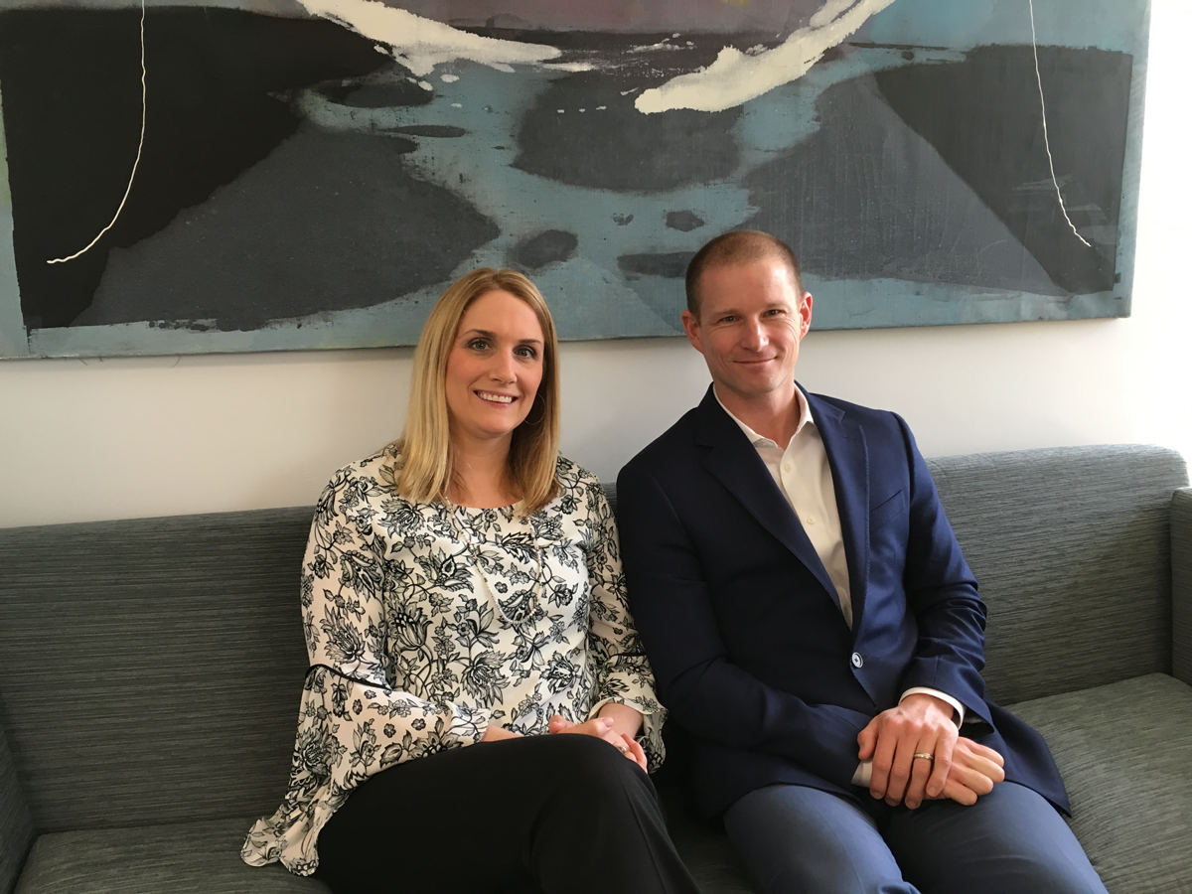
Colleen and Mike Hill are no strangers to giving back, and their involvement with United Way is just one of many ways they make a difference in our community. Mike first encountered United Way’s work in the community when a friend invited him to a United Way Celebration event and Colleen first connected with United Way through her nonprofit work.

Mike and Colleen support United Way for many reasons, including the ease of giving, the vetting process United Way agencies go through, the partnership with local businesses and organizations and the community benefit produced through leverage. Colleen mentioned “The multiplier effect is one of the reasons we give. When thousands of us give together, we can really make an impact.”

The Hills encourage others to connect with United Way as well. Mike said, “There are so many ways to get involved. Everyone can find a way to do their part. I would encourage United Way supporters to spread the word. Invite people in your network to attend an event or to be a part of a volunteer experience.”

YOU CAN MAKE AN IMPACT LIKE MIKE & COLLEEN:

- Fill out your pledge form to make a donation to United Way. Your gift makes an impact in the areas of education, financial stability, health and basic needs in Ottawa County.
- Interested in volunteering? Look for opportunities in your workplace, or view opportunities online by visiting www.OttawaUnitedWay.org and clicking on “Volunteer.”

4. Video Links

Learn more about United Way with the following videos:
United We Fight, United We Win in Ottawa County: https://www.youtube.com/watch?v=d6P5pTZH-KE
United We Fight, United We Win, United Way Worldwide: https://youtu.be/D2T1rFWjy7s
Meet Fred: https://www.youtube.com/watch?v=gbQ1nylSGhM
GOCUW 2020 Campaign Video - Feeding America: https://vimeo.com/464197993
GOCUW 2020 Campaign Video – Good Samaritan Ministries: https://vimeo.com/465754644
GOCUW 2020 Campaign Video - Mosaic Counseling: https://vimeo.com/465751776
GOCUW 2020 Campaign Video - Call 211: https://vimeo.com/465452354
Volunteer - Erin Zylman: https://www.youtube.com/watch?v=kyYILIYNw4Y
Donors - Mike & Colleen Hill: https://www.youtube.com/watch?v=_-XFDHw4AWE
Advocate - Johnna Staat: https://www.youtube.com/watch?v=m46FyTmlPBg

